Guest Speaker Session: Minnesota School Behavioral Health Conference
Wednesday, November 4, 2026

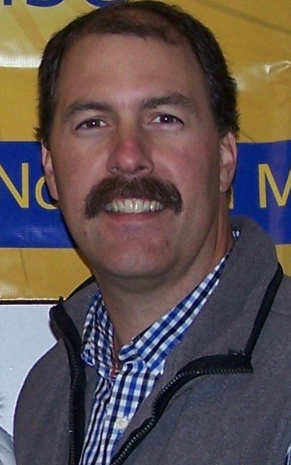
Scott A. Nyegaard, M.S., is an Industrial/Organizational Psychologist and also holds a Bachelor of Science in Applied Psychology from Bemidji State University. He is the CEO and Founder of Legacy Group, LLC, an agency specializing in evidence-based trainings.

25+ years in the Helping Fields has been part of his journey, working largely with adolescent populations. Much of his energy is expressed by promoting a Strength Based approach in people and agencies.

Scott was the Treatment Director for a juvenile facility in Upper Minnesota from 1998-2015, where he had oversight in all programming, staff recruitment and training, client treatment implementation and budgeting. This program was licensed for 12–19-year-old male and female participants, with a high population from American Indian Tribes.
In 2010, Scott founded Legacy Group, LLC, a consulting agency, and developed this venture over the next five years until it grew into a full-time commitment. A primary purpose of this agency is to invest in people and help them fulfill their legacy. Too often individuals chase the concept of ‘someday’. This can often lead to missing out on the present, where we should be investing our time and energy. ‘Live the Legacy you want to leave’ is the message he shares during his keynotes.
Scott has trained in 49/50 states and led several international trainings in Ireland, Canada, Philippines, and Uganda. He has trained thousands of participants who are committed to learning Evidence Based Programs and skills.
Cultivating Hope with the Hopeless: A Motivational Interviewing Strategy
Working with individuals who appear resistant, discouraged, or hopeless can be one of the greatest challenges for helping professionals. This interactive session explores how Motivational Interviewing (MI) can be used to strengthen hope, uncover personal motivation, and foster meaningful change even in the most difficult circumstances. Participants will learn practical MI strategies for engaging ambivalent individuals, evoking their own reasons for hope, and creating conversations that inspire movement toward positive change. Ideal for counselors, social workers, probation officers, educators, and anyone working in the helping professions.

